**SEQUENCE DIAGRAM**

USER

HOUSE RENTAL SYSTEM

DATABASE

LOGIN

AUTHENTICATION RESPONSE

SEARCH CRITERIA

RETRIEVE HOUSE LISTING

HOUSE LISTINGS

SELECT HOUSE RETRIEVE HOUSE DETAILS

HOUSE DETAILS

BOOK HOUSE UPDATE HOUSE STATUS

CONFIRM BOOKING

**FLOWCHART**

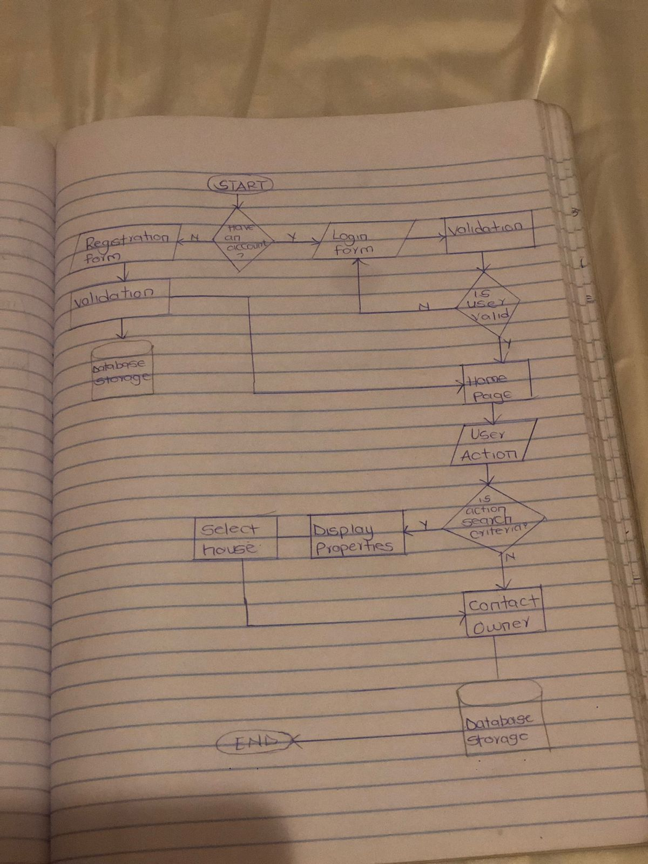

**USE CASE DIAGRAM**

LOGIN

SEARCH HOUSE

ADMIN

USER

MANAGE BOOKINGS

BOOK HOUSE

VIEW DETAILS

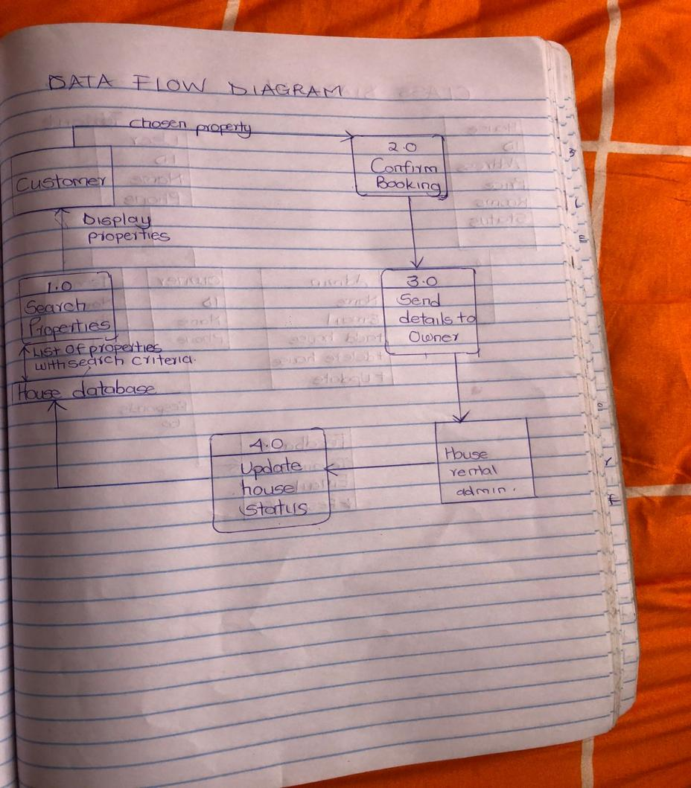

**DATA FLOW DIAGRAM**

**CLASS DIAGRAM**

